**Visuals on Power Bi**

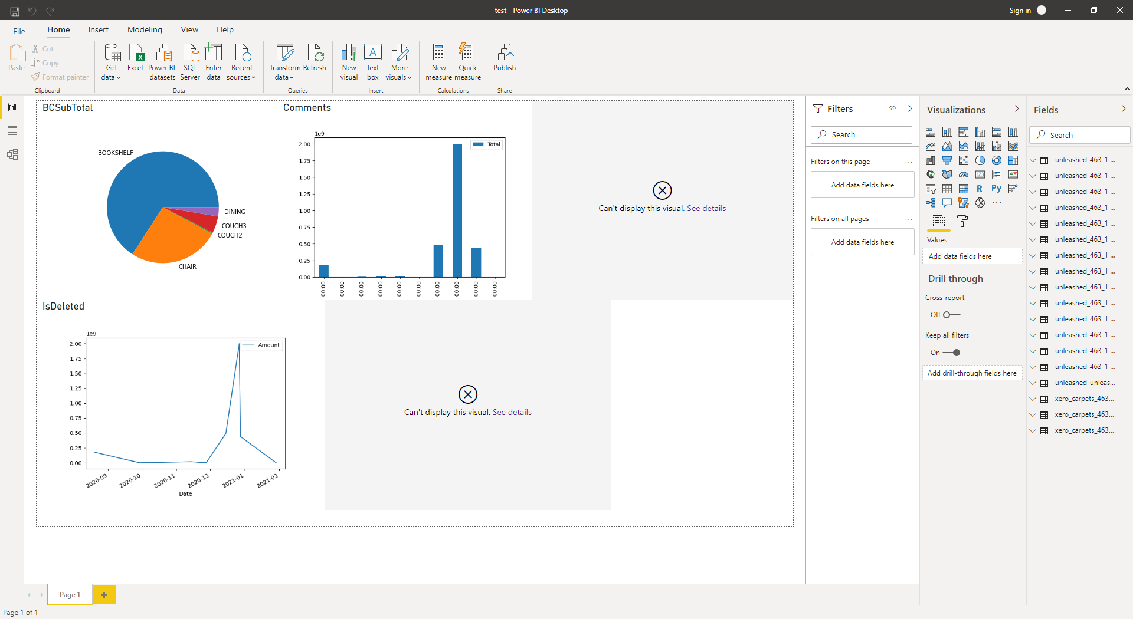

**Pros**

* Since we need scripts for API calls, user cannot do anything. There is no interaction. And graphs are older. Hence no pros.

**Cons**

Python visual is an excellent feature to use with Power BI, but it has few limitations:

* Write lengthy and repetitive scripts for each graph
* A dataset of maximum 150,000 rows can be used for the Python plot. Not more than this.
* We cannot prepare an interactive image with it.
* Python script will give a timeout error after 5 minutes of execution
* Python plots cannot be used for cross-filtering.
* The following Python packages (non-Intel MKL) are currently supported:
  + Matplotlib
  + NumPy
  + Pandas
  + Scikit-learn
  + SciPy
  + Seaborn
  + Stats model

**Visuals on DASH**

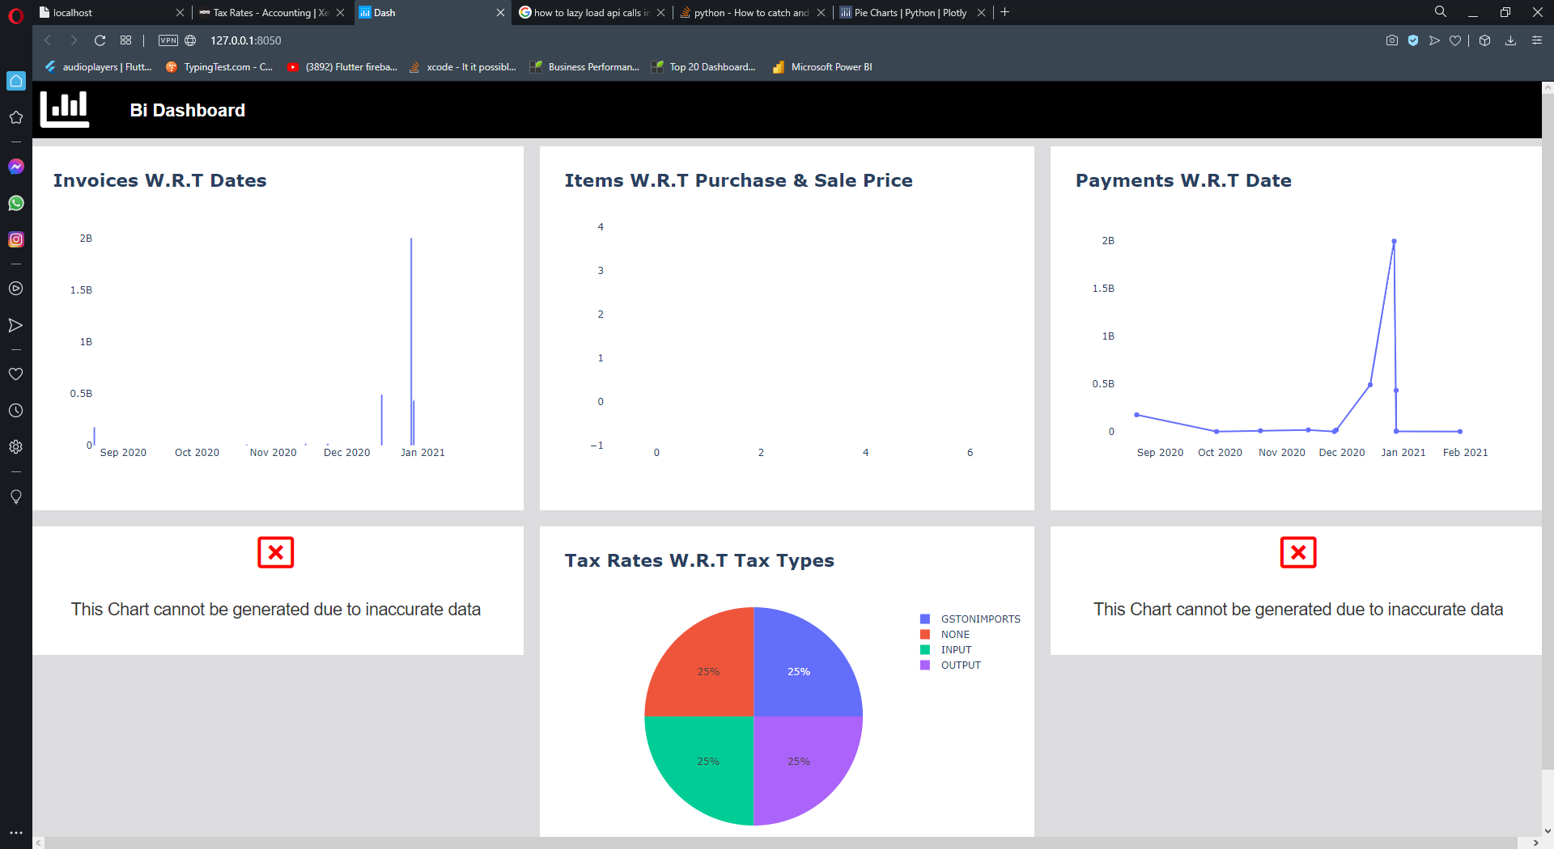

**Pros**

* The graphs here are interactive.
* More control over data
* Can be changed easily for more appealing views.

**Cons**

* The logic is rather complex
* The loading
* time for the current approach is a lot, I would have to look for other logic.

**Visuals on Klipfolio**

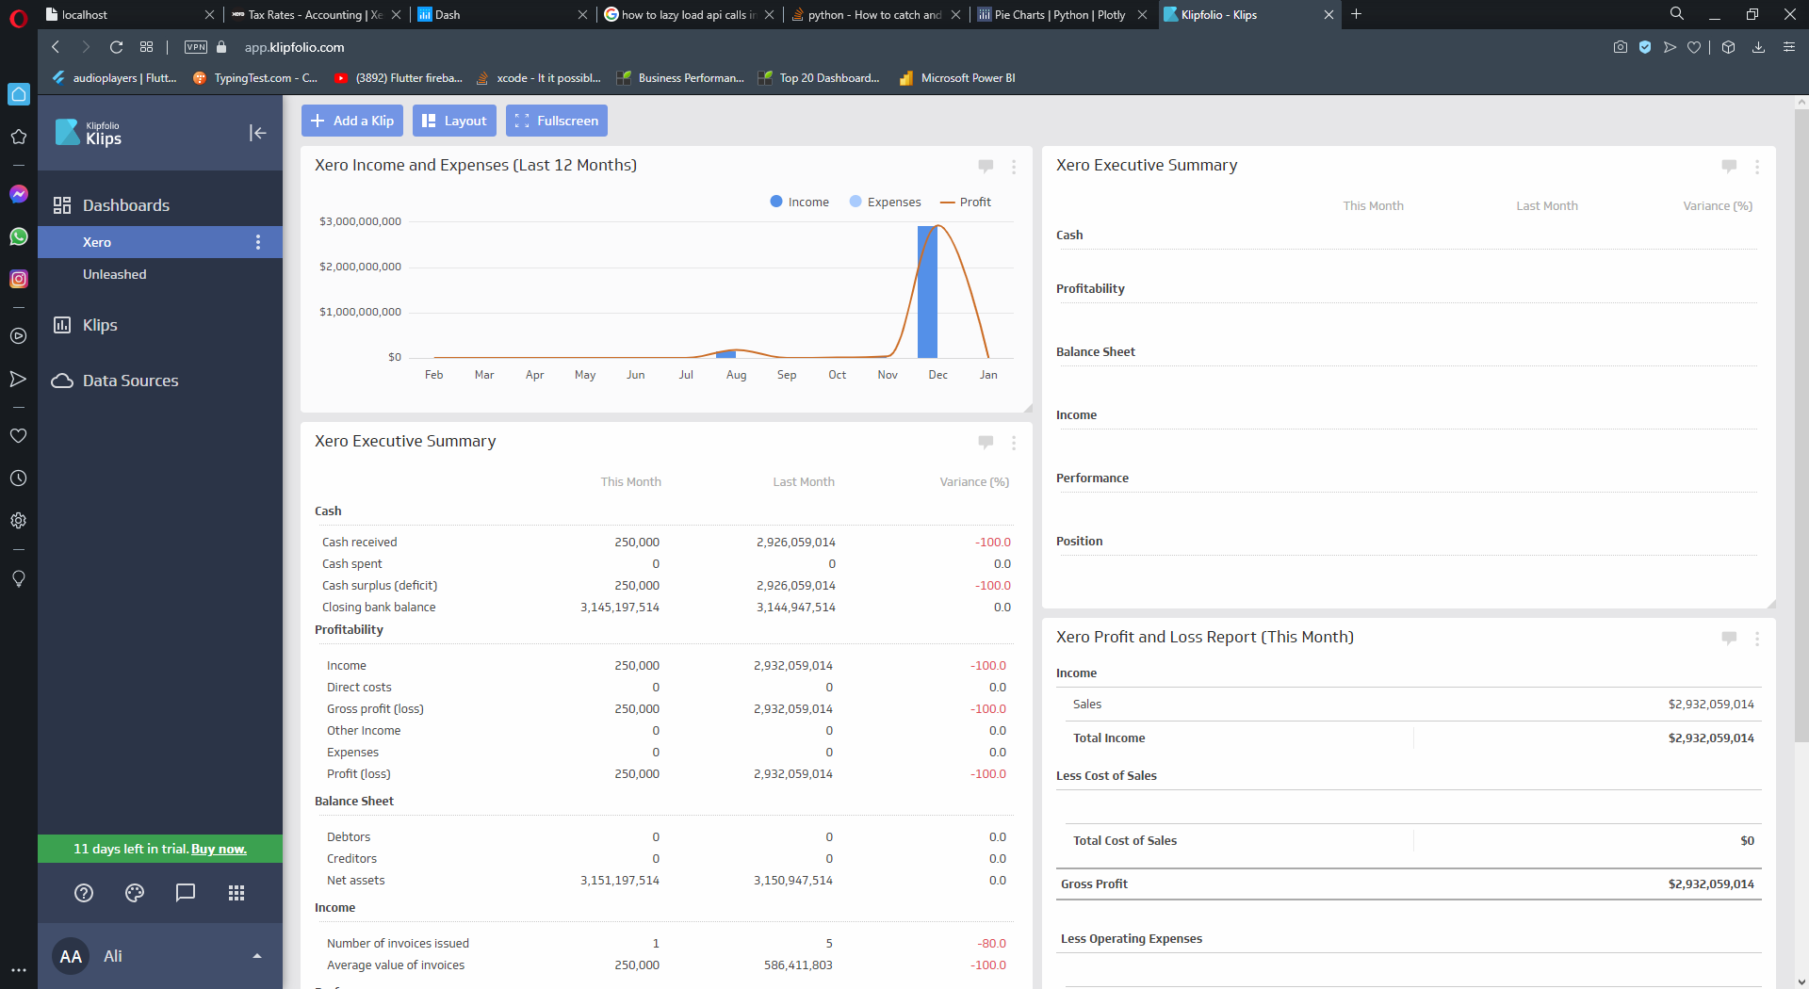

**Pros**

* The graphs here are interactive.
* Graphs are visually appealing.
* Less loading time and refresh does not change the front view.
* Better handling of APIs

**Cons**

* Buying the package
* Graph editor is complex, would need to learn their query system.